**Admin Form**

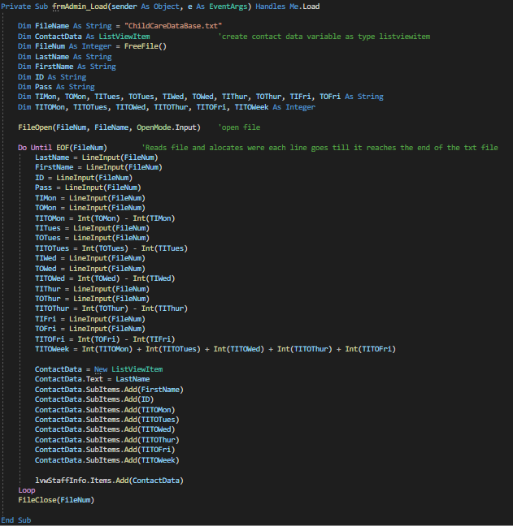

This sub is used to read/load a text file into a list view, first each line from the text file is read and allocated a variable. E.g. line 1 of the text box is “LastName.” Then using specific variables created from the text file a small equation is done to complete a calculation. But due to time none of the variables were properly formatted. Next in the lines starting with “ContactData” specific variables are read and printed into the list view box.

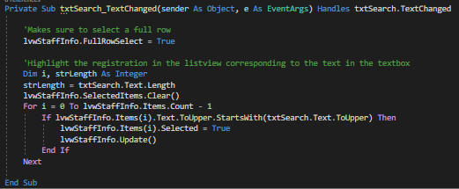

This small section is programmed for the search function. When typing in the search textbox the list view is read in the “ID” column for the *letters* from left to right of the specific box.

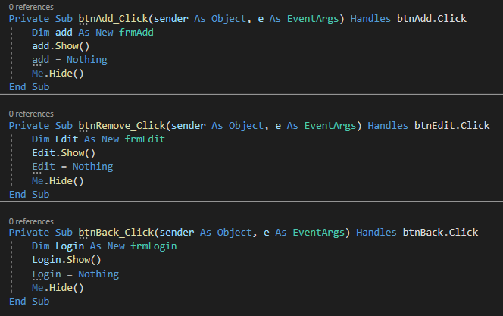

This I 3 different sections of code all doing very similar actions. These are the buttons used to go between forms using a set order of instructions.

**Edit/Remove From**

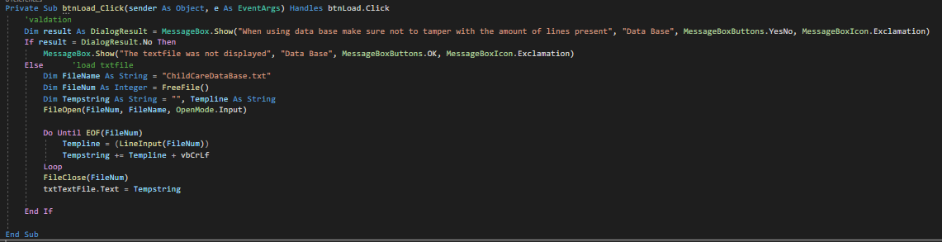

This is using a button to load text form a text file to a text box. When pressing the “Load” button will first display a message box warning not to miss use the file, the after the user accepts the file will open. The text is read and printed in the “Do Until” command to the text box till all lines have been read.

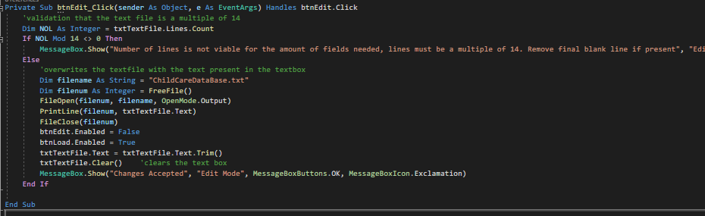

This code is used for the edit to create changes to the original text file when it was printed to the text box. First Validation is used to ensure that the total amount of lines present in the text box is a multiple of 14. If not, the edit function will be stopped till the user fixes it. Next the button will send instructions for the text box to overwrite the text file replacing, removing or even adding new lines. A message box is then displayed confirming that all changes were done

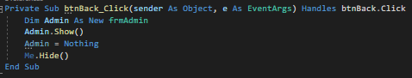

Back button…. Yep. Plain, simple, and efficient!

**Add From**

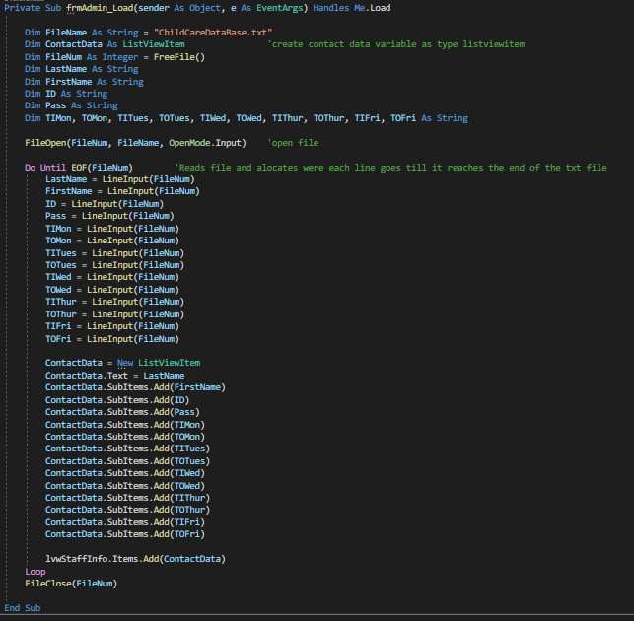

This sub is used to read/load a text file into a list view, first each line from the text file is read and allocated a variable. E.g. line 1 of the text box is “LastName.” But due to time none of the variables were properly formatted. Next in the lines starting with “ContactData” specific variables are read and printed into the list view box.

This large sub can be split into two parts. Validation and Function

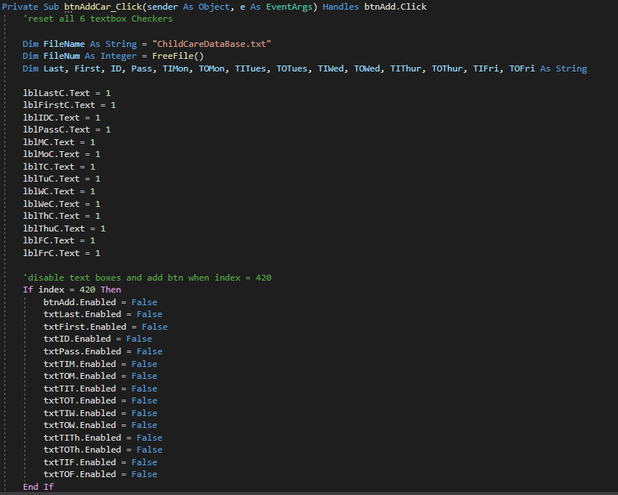

This Part of the code is the validation. If the index of the textfile/ number of lines is equal to 420 then the text boxes to add a new member will be disabled so the user is unable to add anymore members.

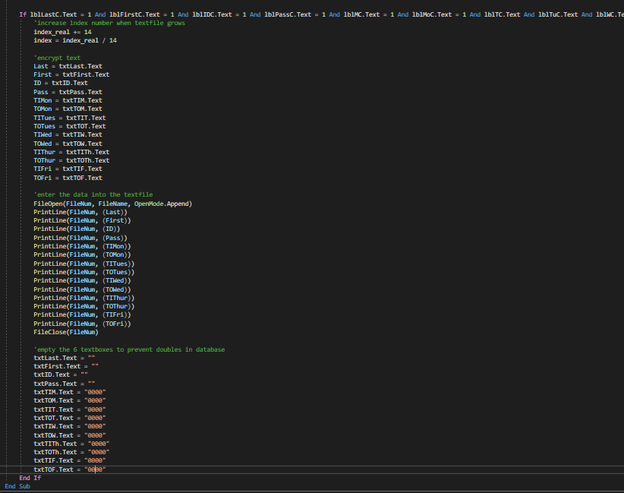

This half of the sub is the main function of the form. This, if the number of members is not exceeded, will add new members of the staff to the text file. Variables that were created earlier in the code are set a specific box collating with there name and line they will be printed in. next the variables are used to read the text box and print new lines into the text box. After this happens all the text boxes are set to be either empty or have “0000.” No formatting was done due to time constraints

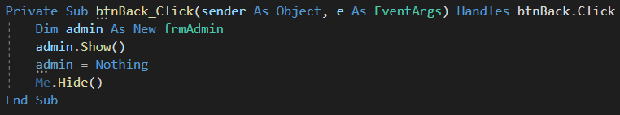

**YOUL NEVER GUESS THE FUNCTION OF THIS ONE! MWA HAHAHA.**